Accessibility Standards Canada

Annual Public Meeting
May 31, 2021

Get to know us!

- Created in 2019 under the Accessible Canada Act
- “Nothing without us” is at the heart of our mandate
- We fund research and develop standards to make Canada more accessible.

Governance
- Philip Rizcallah, CEO, is in charge to oversee day-to-day operations
- Managed by a Board of Directors
  - Majority-led by people with disabilities

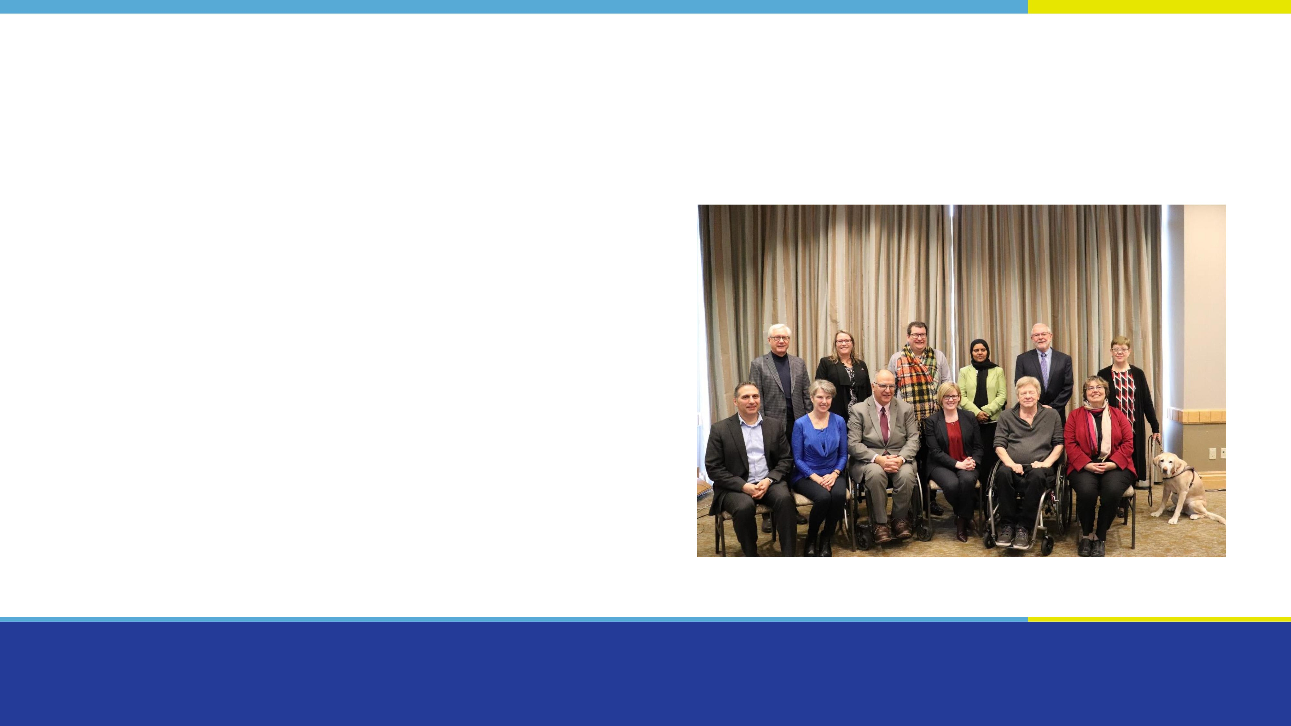
Board of Directors
- Paul-Claude Bérubé, Chairperson
- Mary Reid, Vice-Chairperson
- William Adair
- Kory L. Earle
- Maureen Haan
- Penny Hartin
- Rabia S. Khedr
- Brad McCannell
- Dr. Joe McLaughlin
- Laurie Ringaert

Mandate
- Develop and review accessibility standards for organizations under federal jurisdiction
- Support research on the identification, removal and prevention of barriers
- Share best practices about the removal of barriers.

Priority areas

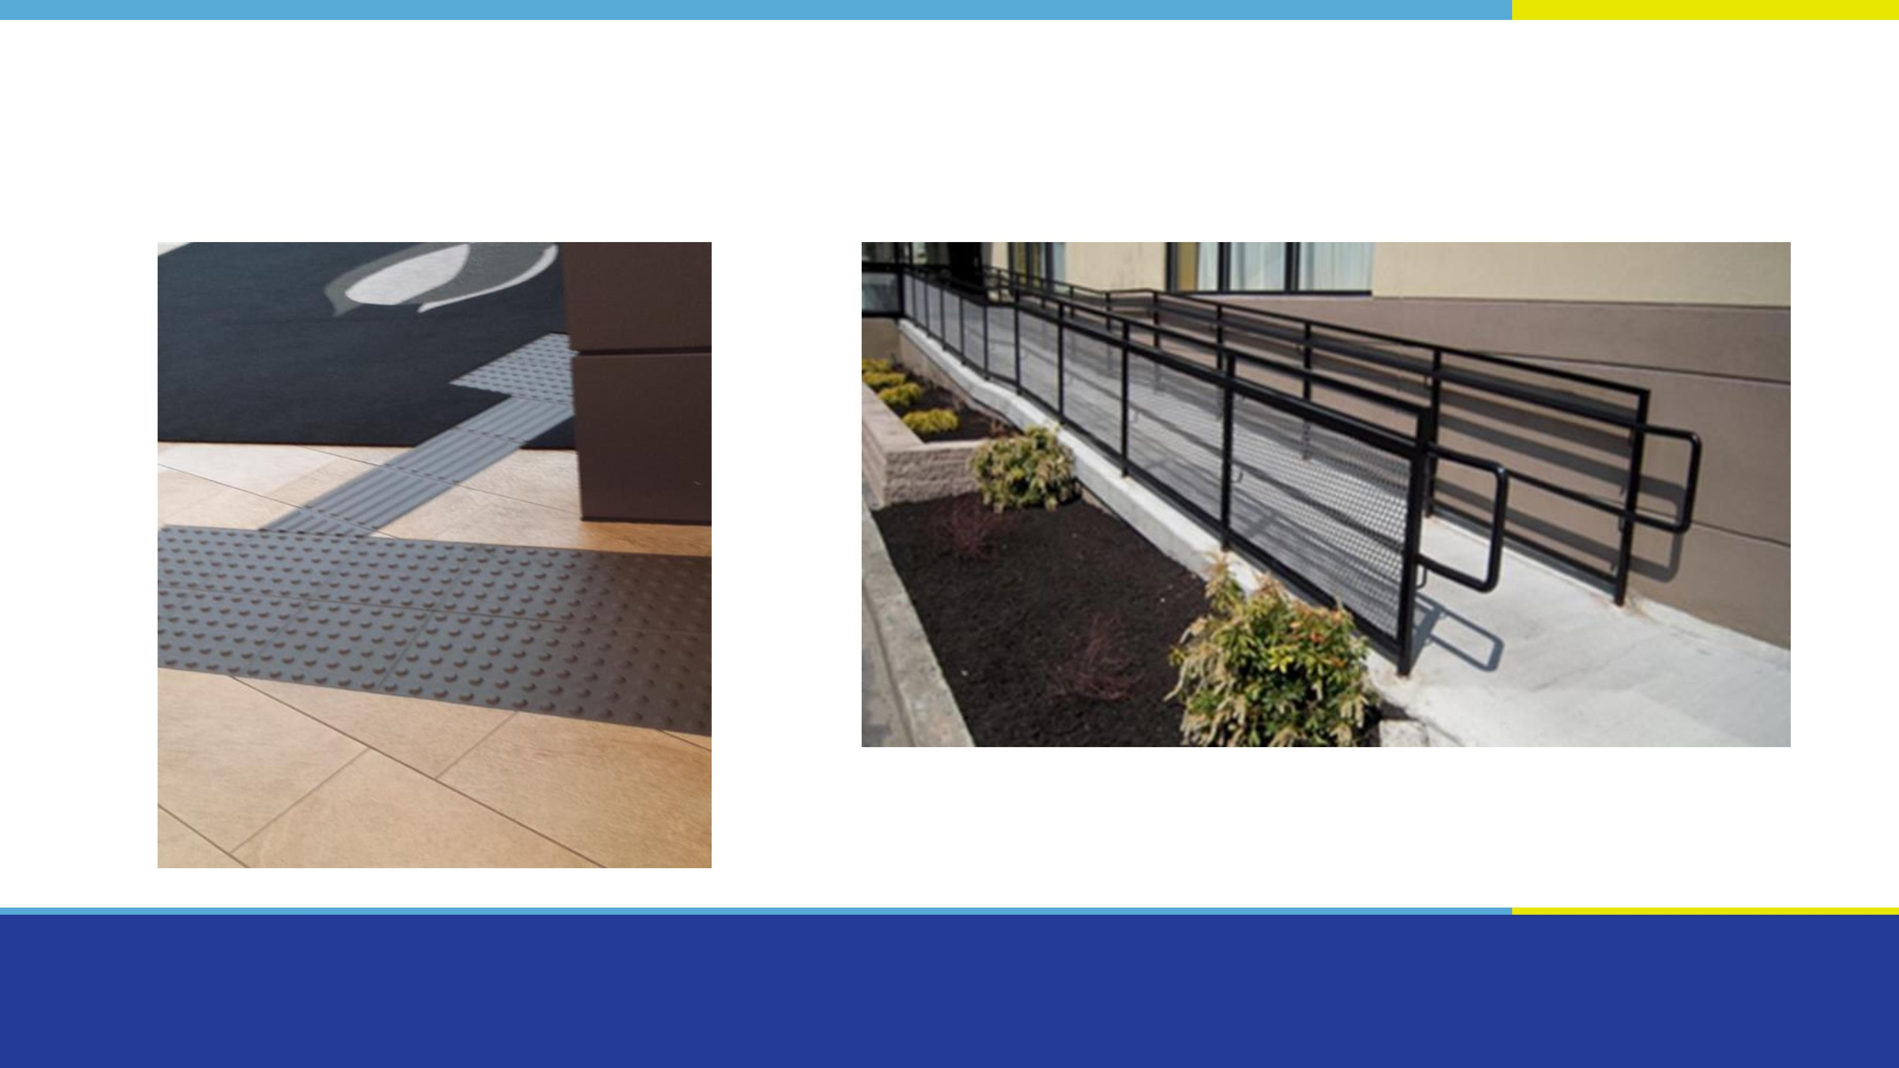
Built environment

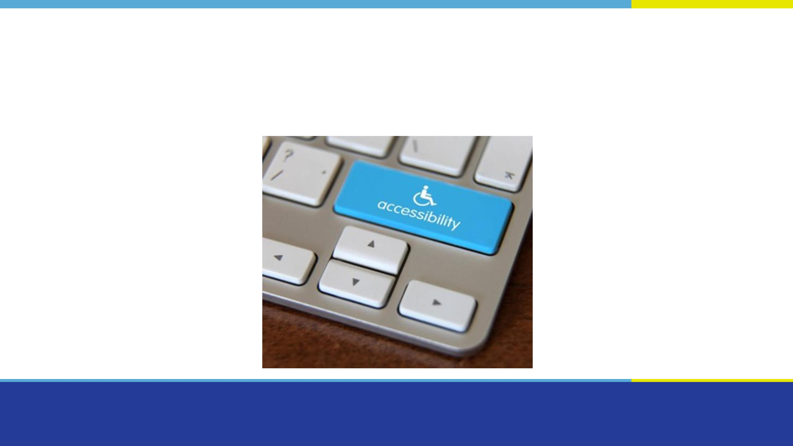
The buying of goods, services and facilities

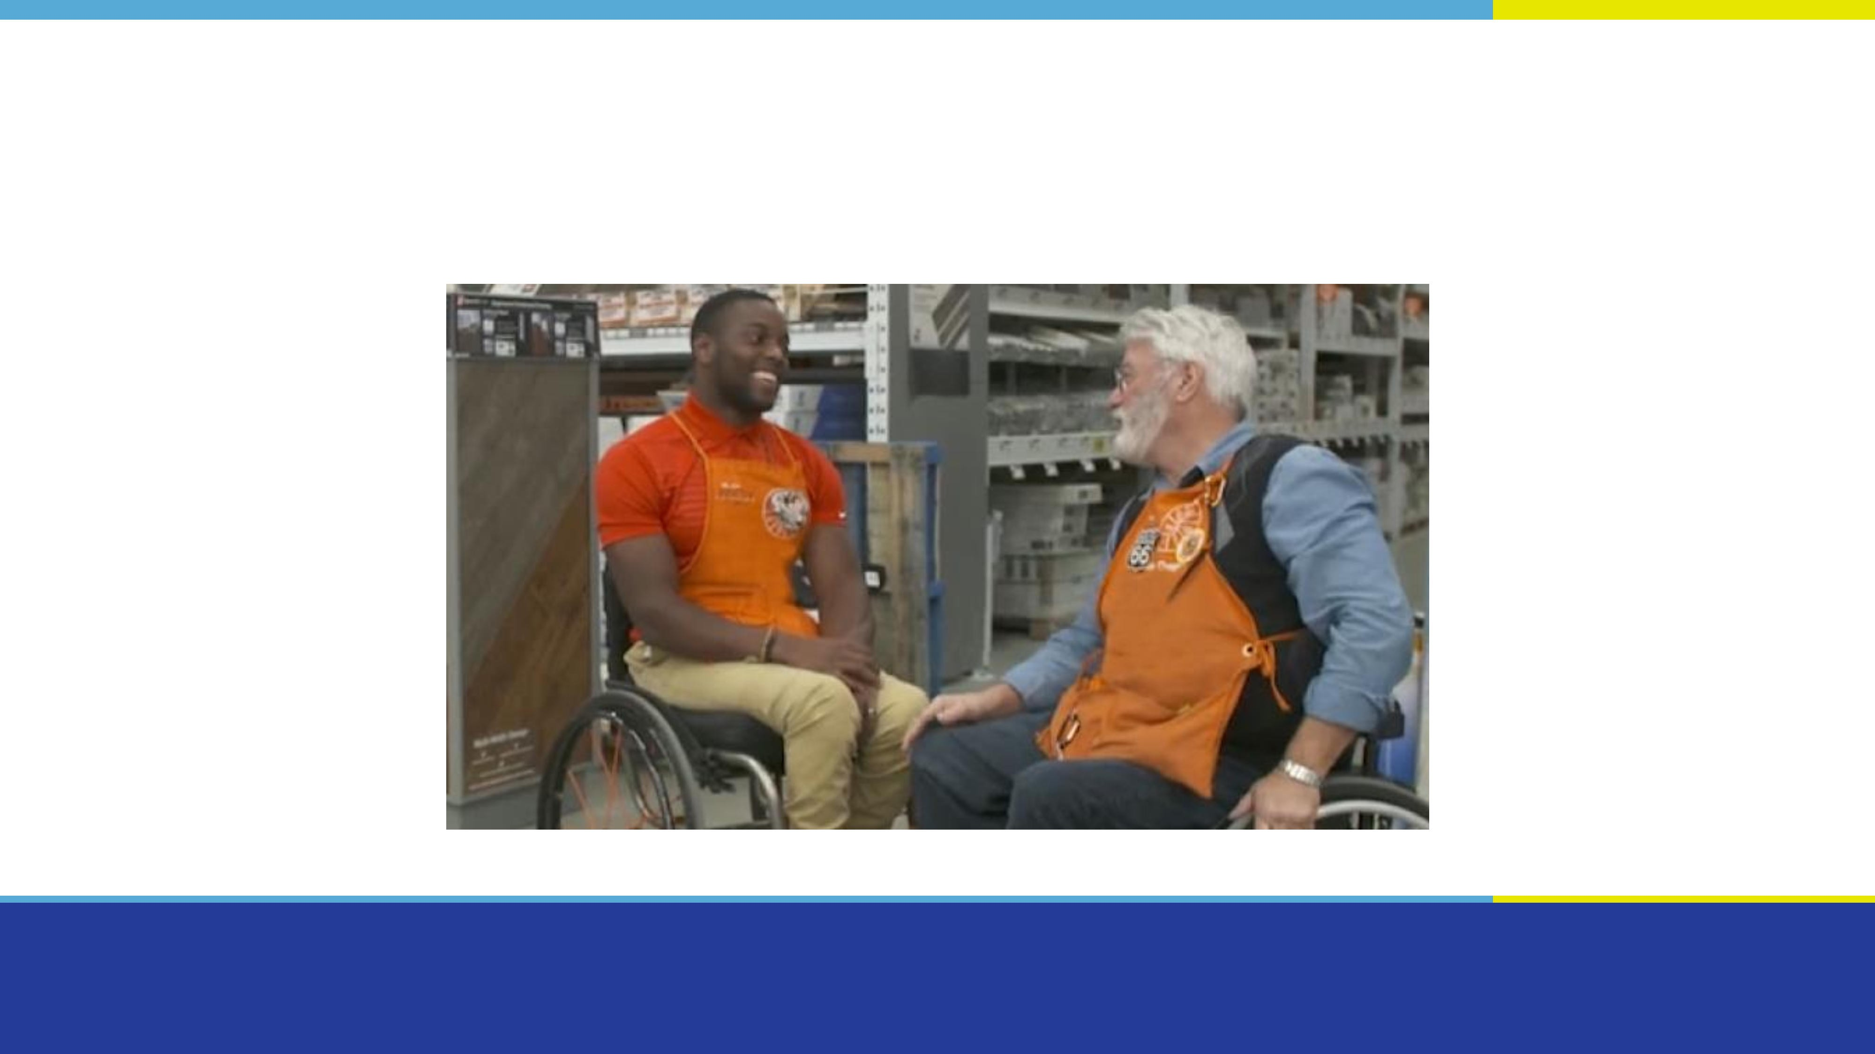
Employment

Communications (not including ICT)

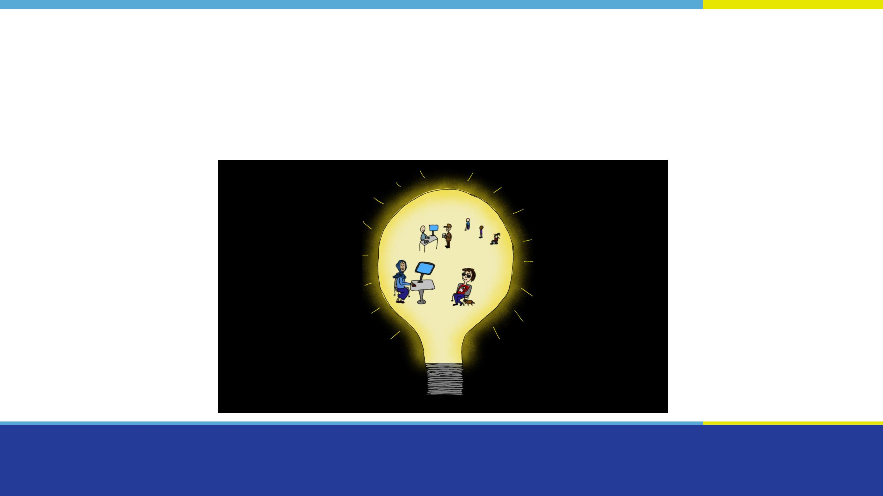
Design and delivery of programs and services

Transportation

Information and communication technology

Where we are now?

Funding research [1 of 2]
  - The research we fund will help inform the development of standards.
  - To date, we have funded 24 projects on:
    - Employment
    - Built environment
    - Accessible communications
    - Information and communication technologies
    - Emergency measures
    - Accessibility in Indigenous communities

Funding research [2 of 2]
- Examples of projects include:
  - Identifying barriers to accessibility in national parks
  - Environmental scan on accessibility standards in Indigenous
Communities
  - Study of evacuation guidelines for persons with disabilities in urban centres during emergencies

Creating Standards [1 of 2]
- Technical committees creating standards for:
  - Built environment
  - Emergency egress
  - Outdoor spaces
  - Plain language
  - Employment

Creating Standards [2 of 2]
- Ongoing work with the CSA Group on standards for:
  - Accessible electronic payment terminals
  - Accessible design for the built environment
  - Accessible housing (with the Canada Mortgage and Housing
Corporation)

Guidelines related to COVID-19
- Accessibility guidelines on emergency situations:
  - Return to work and work from home
  - Communications
  - Service Delivery
  - Inclusive emergency responses
- Created in collaboration with stakeholders

Consulting Canadians

First consultations with Canadians
- Closed our first public consultation on September 30, with almost 600 responses.
- Consultation report available on accessible.canada.ca

Overview of consultations
- We asked:
  - How we should continue to engage Canadians with disabilities
  - Where we should focus our research and standards
- 65% of participants were persons with disabilities

Key findings for engagement
- A flexible and accessible approach is key
- 81% participants preferred group discussions

Research priorities
- Top priorities:
  - Employment
  - Built environment
  - Design and delivery of programs and services
- Participants often raised the importance of intersectionality
- Involving persons with disabilities is important to research

Priorities for standards
- Top priorities:
  - Employment
  - Built environment
- All priority areas are interconnected
- Involving persons with disabilities is important for standards development

“Nothing without us”
- The results of our consultations inform our standard development and research priorities.
- We always want to hear from Canadians, and we will continue to work with you towards an accessible Canada.

Where we are going: 2021-2022

Research priorities
- Accessibility in Indigenous communities
- Built environment, with a focus on heritage buildings
- Communication, other than plain language
- Design and delivery of programs and services
- Information and communication technology
- Procurement (buying) of goods, services and facilities

Priorities for standards [1 of 2]
- We will set up technical committees to develop standards on:
  - Acoustics
  - Wayfinding (including signage)
  - Emergency measures (particularly during a pandemic)
  - Procurement (the buying of goods, services and facilities)

Priorities for standards [2 of 2]
- We will seek accreditation as a standards development organization.
- We will work with provinces and territories.
- We will continue working with other organizations to develop standards.

Conclusion
- We have a lot of work ahead of us.
- We are excited to keep moving forward with you towards an accessible Canada!

Thank you!

Questions?

Click on “Participate”
Or send us an email:
ASC-NAC@canada.gc.ca

