Emergency measures and persons with disabilities

Paul LUPIEN
May 31, 2021

Me from 1990 to now
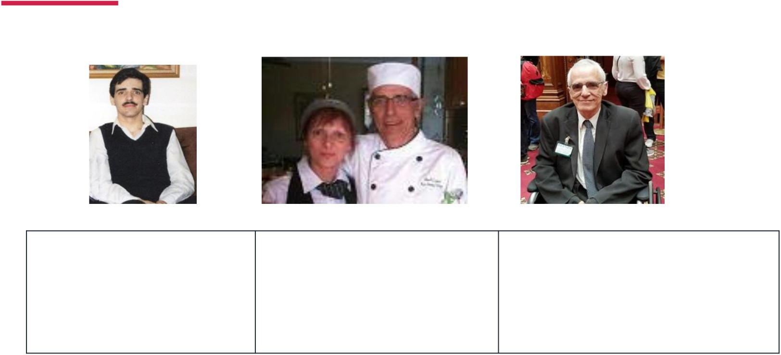

In the 90s Paul Lupien between

2013 and 2017
Paul Lupien between

2017 and today

Bouchard-Taylor Commission [1 of 2]

The distinction between choice and constraint
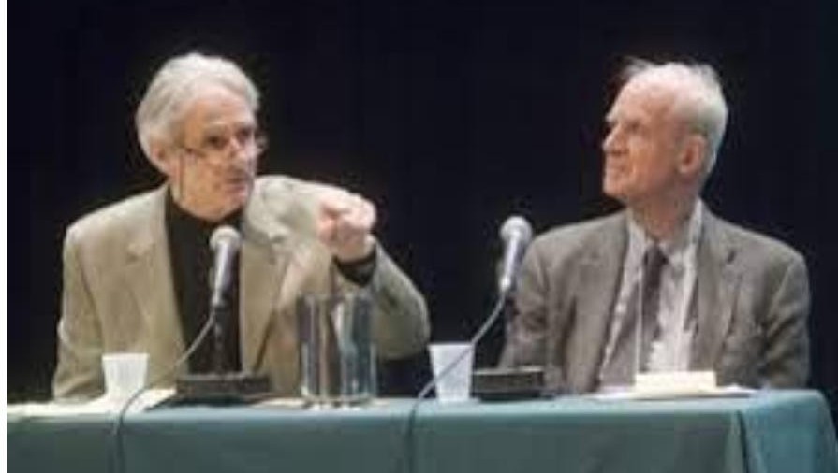
“The rightfulness of an adjustment that allows, for example, a female or a male student to wear a headscarf or a kirpan, respectively, is not obvious to everyone. Similar exemptions may be granted for health reasons: a young girl must cover her head on her physician’s orders or a diabetic child must bring a syringe and a needle to school.”

Bouchard-Taylor Commission [2 of 2]

The distinction between choice and constraint
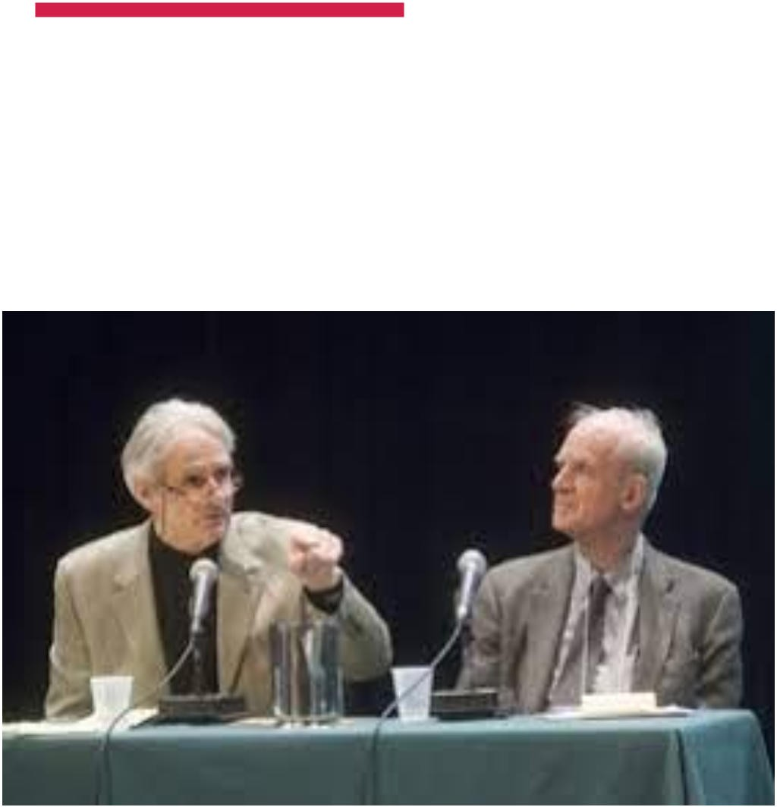

“No one would dream of objecting to such exemptions. We also know that accommodation aimed at ensuring the equality of pregnant women or the physically disabled is readily accepted.

Grounds of discrimination in Quebec
Commission des droits de la personne et des droits de la jeunesse: 2018-2019 Activity and Management Report
Open cases by area and ground of discrimination
 | Area |  |  |  |  | Total
Ground | Work | Housing | Legal act / goods and services | Access to public transportation and public places | Other | 2018-2019 | 2018-2019 in %
Disability | 128 | 6 | 53 | 34 | 3 | 224 | 36%

Ice storm crisis, January 1998 [1 of 5]
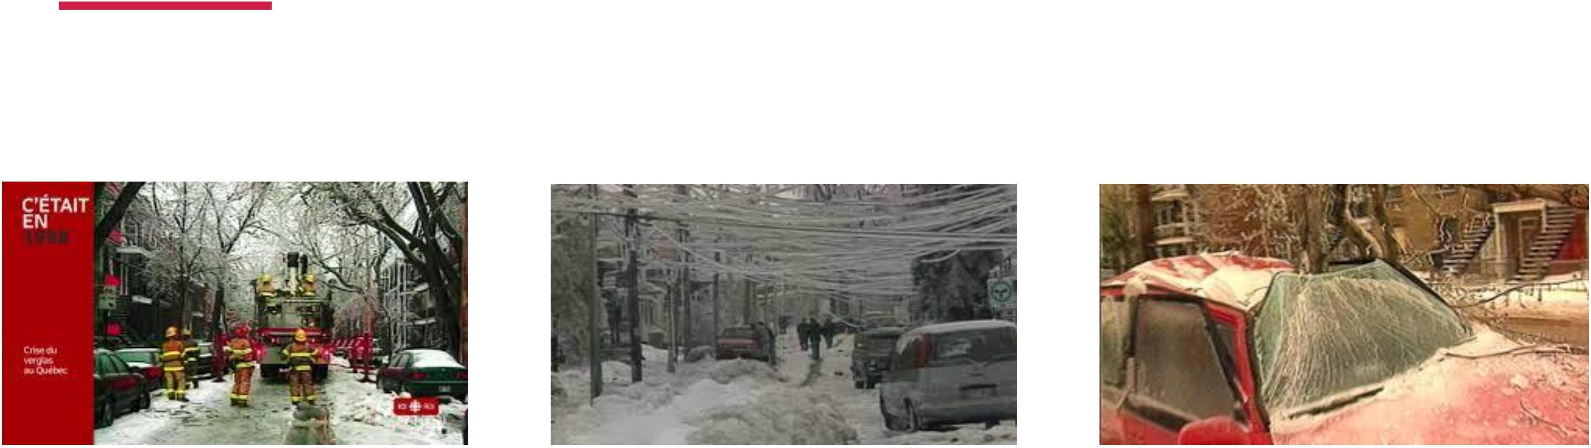

Ice storm crisis, January 1998 [2 of 5]

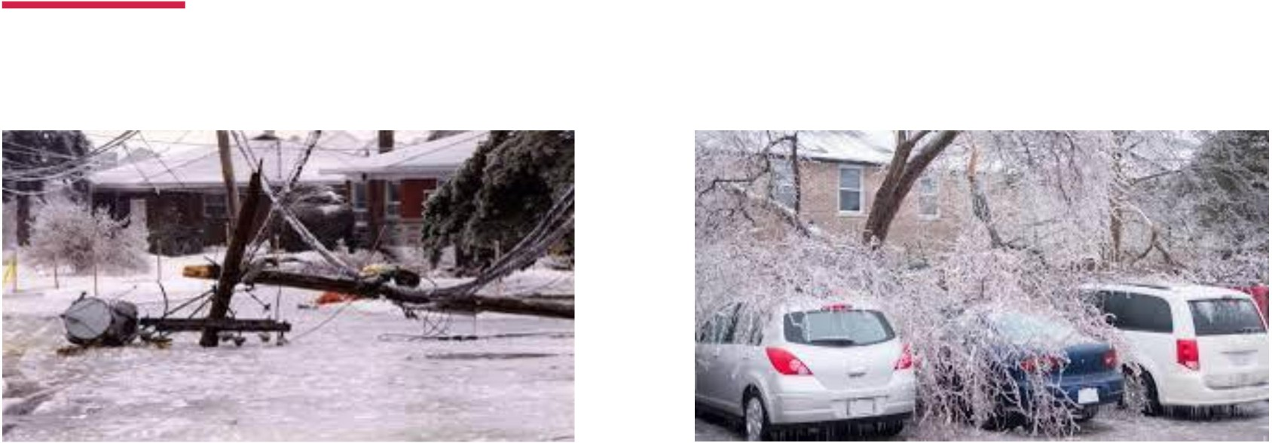

Ice storm crisis, January 1998 [3 of 5]

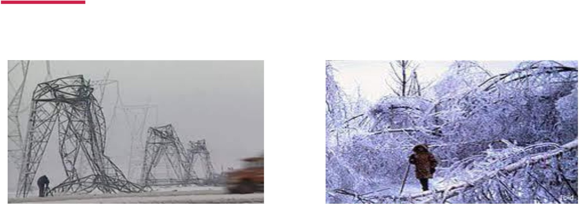

Ice storm crisis, January 1998 [4 of 5]

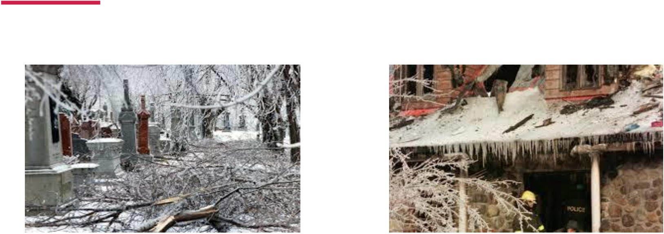

Ice storm crisis, January 1998 [5 of 5]

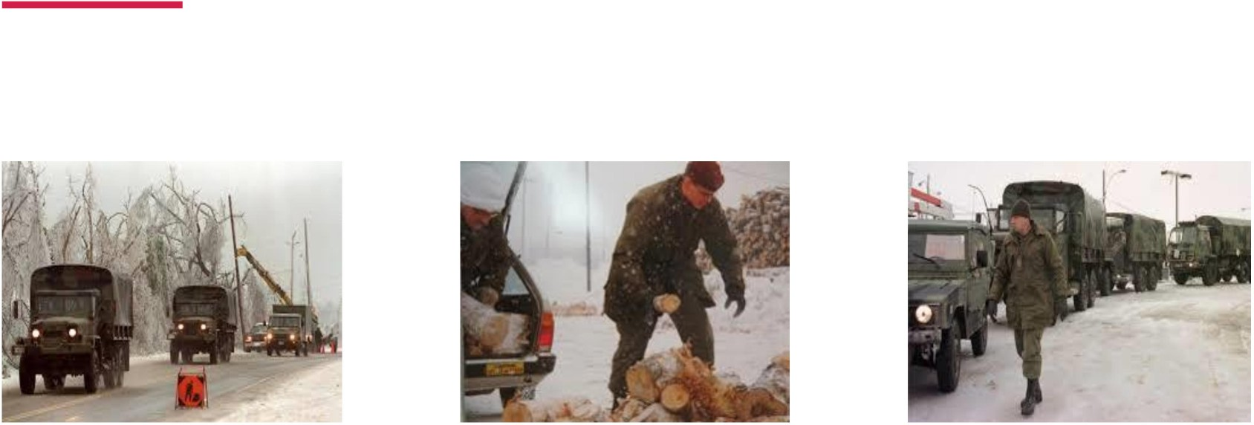

What to do to evacuate each person [1 of 4]
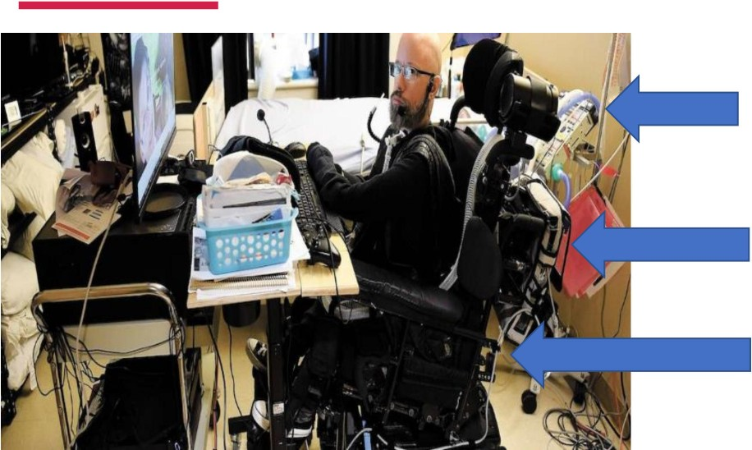

Artificial respirator (essential)

Essential equipment connected to his electric wheelchair
Electric wheelchair – over 350
pounds

- Good thing my friend Jonathan is not obese. However, his wheelchair is very heavy, and it is essential to his survival.
- Can we evacuate him with his wheelchair if he is on the 10th floor of a building?

What to do to evacuate each person [2 of 4]
Imagine a 47-year-old person with an intellectual disability, who has always lived in the same house as his parents who are over 70 years old.
- How do we maintain routines when they are in the gymnasium, in a noisy environment and among strangers?
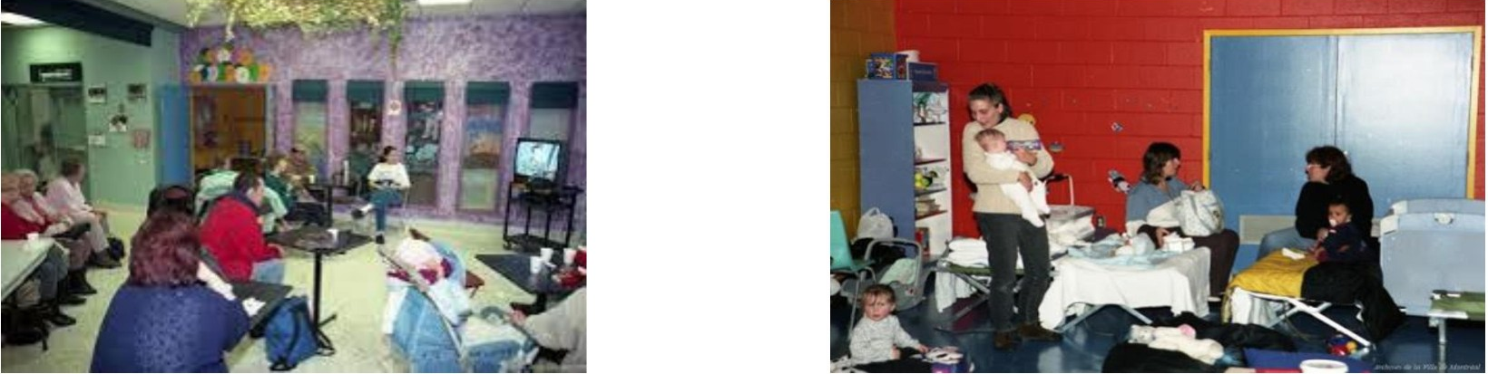

What to do to evacuate each person [3 of 4]

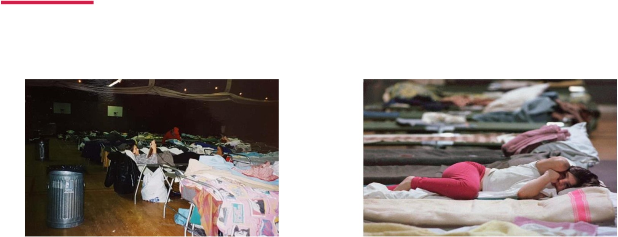

What to do to evacuate each person [4 of 4]
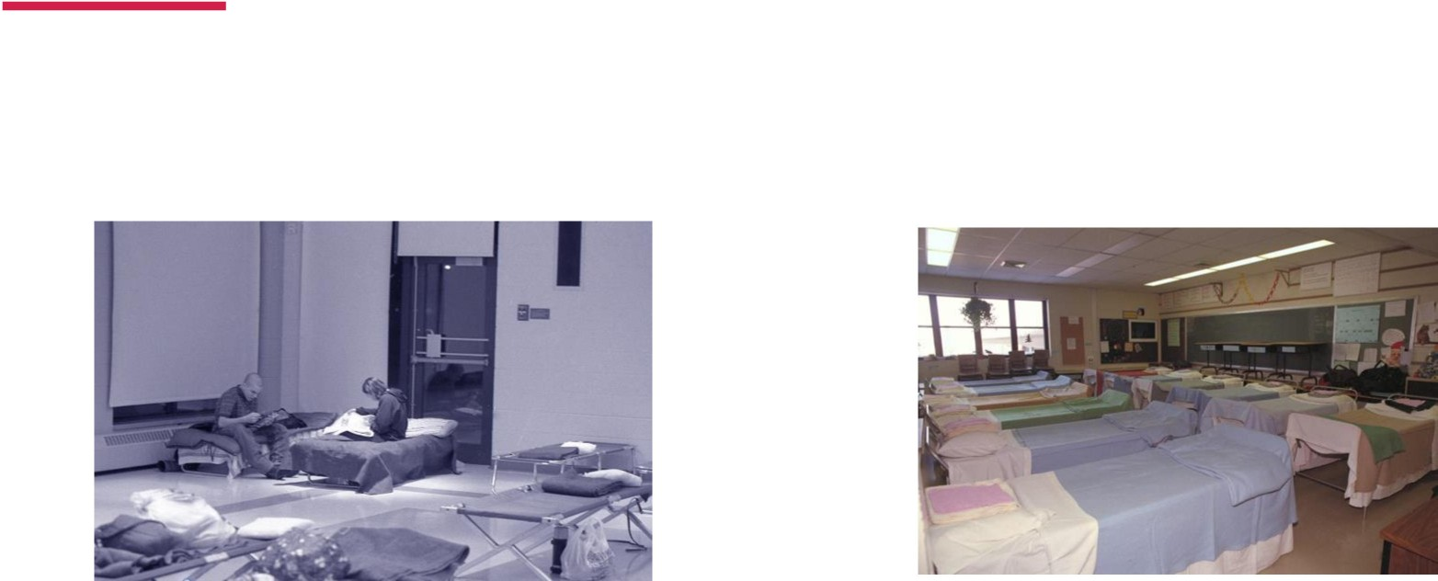

1998 Ice storm crisis
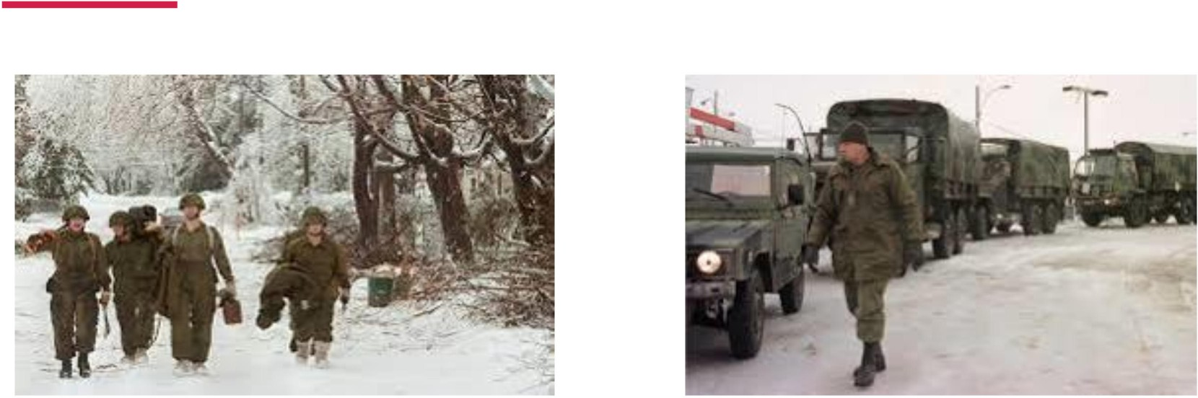

Special thanks to the military!

Findings on solidarity

My city Other cities And sometimes…

Findings on missing solutions [1 of 2]

- Confidentiality and free choice:
  - Having the right to ask to lift my confidentiality in some emergency situations
- Resilient communities:
  - Why not “Emergency Angels”?
- Standards for jobs:
  - Training for any person who may have to intervene with persons with disabilities

Findings on missing solutions [2 of 2]
- Understanding locations through the people who live there:

  - Which areas have the biggest population of persons with disabilities?
  - The need to build an ability-based analysis
- Learning from our mistakes:
  - Looking at our past and current mistakes with the people who have been affected for a common future.

Conclusion

