## Slide 1

Accessibility Standards Canada’s Annual Public Meeting  
May 22, 2024. Leading change to make Canada accessible and include all people.

No Alt Text.

## Slide 2

**To Access American Sign Language Interpretation, Click on “Sign language”**



Alt Text - Image: Sign language button in the webcast player. Shows two white hands on a black background making the sign for American Sign Language.

## Slide 3

To See Captions, “Click on Captions”

**Captions button in the webcast player. Shows a tooltip with lines and a pen making the sign for captions.**

Alt Text: Image - Captions button in the webcast player. Shows a tooltip with lines and a pen making the sign for captions.

## Slide 4

Technical Issues?

Click on “Help”



Alt Text: Image - Help Button

Send and email to: [helpdesk@collaboratevideo.net](mailto:helpdesk@collaboratevideo.net)

## Slide 5

Slow Connection?

Try Turning off the video:

1. Click on “Settings”



Alt Text: Image – Settings Button.

Choose “Audio Only”

## Slide 6

Land Acknowledgement

We pay respect to the Algonquin people, the traditional guardians of this land. We acknowledge their longstanding relationship with this territory, which remains unceded. We pay respect to all Indigenous people in this region, from all nations across Canada, who call the National Capital Region home. We acknowledge the traditional knowledge keepers, both young and old. And we honour their courageous leaders: past, present, and future. We encourage you to learn about the Indigenous peoples and lands in your local area.

## Slide 7

Our Work – Key Achievements

* Funded 32 new research projects
* Consulted the public on 3 draft standards
* Since 2022, ASC has attended more than 100 stakeholder meetings, events and conferences
* Created 3 new technical committees
* Signed 6 Memoranda of Understandings
* Named a top employer in the National Capital Region (NCR)

## Slide 8

Our Work - Key Plans

* Advancing 18 standards currently at different stages of development
* Publishing our first 2 finalized standards
* Launching a call for proposals for the 2025-2026 funding cycle
* Creating 2 new technical committees: tourism and procurement processes
* 2 more standards undergoing public review

## Slide 9

Centre of Expertise

* 18 standards in development and published
* 86 research projects, representing over $43 million in funding
* All standards and research are free of charge

[accessible.canada.ca/centre-expertise](https://accessible.canada.ca/centre-expertise)

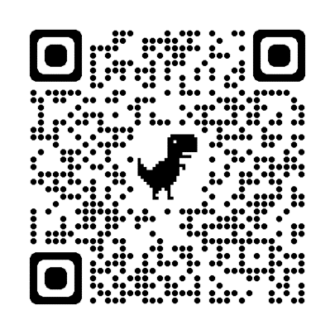

Alt Text: Image – QR Code

## Slide 10

How to Get Involved

* Participate in the standards development process:
* Apply to be a member of a technical committee
* Send us your comments and feedback about draft standards
* Apply and/or participate in a research project
* Submit your name for appointment to the Board of Directors
* Visit our Centre of Expertise
* [Subscribe](https://accessible.canada.ca/newsletter-registration) to our newsletter
* Follow us on social media: [X](https://twitter.com/NormesAccesCA), [Facebook](https://fr-fr.facebook.com/NormesAccesCA/), and [LinkedIn](https://ca.linkedin.com/company/normesaccesca)
* Register for our Annual Public Meeting

## Slide 11

Question 1

* What is being done to ensure Canadians experience the same accessibility wherever they live, work and play?

## Slide 12

Question 2

* How will Accessibility Standards Canada’s standards fit in the hierarchy of the National Building Code and CSA Group standards?

## Slide 13

Question 3

* Is Accessibility Standards Canada doing anything to help advance accessibility of housing in the National Building Code?

## Slide 14

Question 4

* Is Will best practices for handling the recruitment process be covered in the employment standard. Specifically, how to handle virtual interviews. Also, how will the standard address reasonable accommodations. Are we moving away from reasonable accommodations to an employee-led and empowered model. What is your advice for organizations looking to change their culture and practice?

## Slide 15

Question 5

* How will invisible disabilities be incorporated in your work? This includes cognitive disabilities as well as and chronic and episodic health disabilities.

## Slide 16

We Want to Hear from You

* Call or email us:
  + 1-833-854-7628
  + [ASC-NAC@canada.gc.ca](mailto:ASC-NAC@canada.gc.ca)

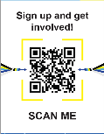

Alt Text: Image – QR Code

## Slide 17

Thank You

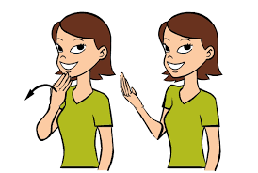

Alt Text: Image - Showing steps on how to say thank you in American Sign Language. Image is a clipart women brown hair green shirt smiling wih her four fingers of her hand on her chin with a arrow directing to move hand outwards. Second image of her shows how far your hand moves out.