
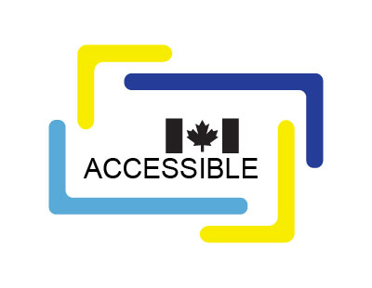
CAN-ASC-2.2 – Emergency Egress (Exit)
Overview of draft standard
No part of this publication may be reproduced in any form without the prior permission of the publisher.
The publication is available in HTML format at https://dev-accessible-canada.pantheonsite.io/en/creating-accessibility-standards/can-asc-22-emergency-egress-exit-0
For more information, or for alternative formats, contact:
Accessibility Standards Canada
320, Saint-Joseph Boulevard, Suite 246
Gatineau, QC J8Y 3Y8
1-833-854-7628
accessible.canada.ca
© His Majesty the King in Right of Canada, as represented by the Minister responsible for the Accessible Canada Act, 2025.

Table of contents
Overview 4
Impact 5
Scope 5
Annexes 6

CAN-ASC-2.2 Emergency Egress (Exit)

Overview
This is the public review draft of the CAN-ASC-2.2 Emergency Egress (Exit) standard.
This Standard is intended to be a best practice in accessibility for the evacuation of people with disabilities. Specifically, those in federally regulated sectors as described in the Accessible Canada Act. Other sectors and organizations in Canada are encouraged to use it, too.
This Standard provides both application and technical specifications relating to emergency egress. It has been developed by a Technical Committee composed of subject matter experts, including:
- people with lived experience,
- regulators,
- fire and emergency personnel,
- architects, and
- interested parties from industry.
It aims to remove physical, systemic, and attitudinal barriers now and in the future.
This Standard is intended to align with:
- CSA/ASC B651:23 - Accessible Design for the Built Environment, and
- relevant human rights codes and legislation, including:
  - the Accessible Canada Act,
  - the Canada Labour Code, and
  - the Canadian Human Rights Act.

Impact
This Standard makes sure everyone can safely leave a building during an emergency. It outlines built environment design principles and procedures that work for all people requiring assistance when evacuating a building in an emergency, including persons with disabilities.
This Standard helps organizations design and improve emergency egress systems so they are fully accessible to people with disabilities.

Scope
The requirements of this Standard shall apply to all the following:
- the design, construction and occupancy of all new buildings,
- the alteration, major renovation (as defined by the National Building Code), reconstruction, relocation and occupancy of all existing buildings, including leased facilities,
- both site-built and factory-constructed buildings, and
- buildings with single stairwells.
The content of the standard expands on 8 key topics developed by a Technical Committee of subject matter experts, listed below:
- Emergency egress for people with disabilities
- Practices and procedures
- Built environment
- Emergency communication
- Illumination and emergency power
- Elevators
- Emergency signage and wayfinding
- Safety equipment

Annexes
Annexes provide more information and context on concepts presented within this Standard. The Standard states general requirements while the annexes provide detail. The list below identifies annexes to read in addition to reading the Standard.
- Annex A: Emergency egress issues for persons with disabilities
- Annex B: Personal Emergency Evacuation Plans
- Annex C: Emergency alerting and communication technologies for persons with disabilities
- Annex D: Emergency evacuation devices for persons with disabilities
- Annex E: Elevators
- Annex F: Bibliography (informative)

