
CAN-ASC-2.9 – Accessible Childcare Centres
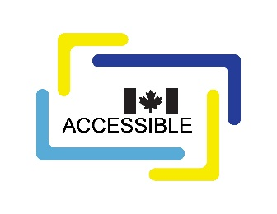
Overview of draft standard
No part of this publication may be reproduced in any form without the prior permission of the publisher.
The publication is available in HTML format at https://accessible.canada.ca/creating-accessibility-standards/can-asc-29-accessible-childcare-centres
For more information, or for alternative formats, contact:
Accessibility Standards Canada
320, Saint-Joseph Boulevard, Suite 246
Gatineau, QC J8Y 3Y8
1-833-854-7628
accessible.canada.ca
© His Majesty the King in Right of Canada, as represented by the Minister responsible for the Accessible Canada Act, 2026.

CAN-ASC-2.9 – Accessible Childcare Centres

Overview
Accessibility in childcare centres is essential to ensure that every child, regardless of ability, can learn, grow and thrive in an inclusive environment.
CAN-ASC-2.9 – Accessible Childcare Centres aligns with the Built Environment priority area of the Accessible Canada Act which aims to create a barrier-free Canada by 2040.
This draft standard outlines requirements for accessible design in childcare centres to create welcoming and inclusive environments for children, families and staff. These requirements help remove barriers to:
- early learning opportunities for children with disabilities,
- childcare access for parents and guardians with disabilities,
- equitable employment and care delivery for staff.
Canada’s disability community identified the Built Environment as a top priority in the Government of Canada’s 2017 report “Creating new federal accessibility legislation: what we learned from Canadians.” Investing in accessibility in childcare centres aligns with broader societal goals of inclusion and equity. It reflects a commitment to the rights of all individuals and demonstrates a forward-looking approach to community development. Creating accessible childcare centres contributes to a more inclusive society where every child can reach their full potential.
This is the first version of CAN-ASC-2.9 Accessible Childcare Centres. It was developed by the Technical Committee on the Existing Built Environment. The committee operates under the supervision of Accessibility Standards Canada.

The Accessible Childcare Centres draft standard includes requirements for:
- inclusive play areas,
- sensory accessibility,
- safety,
- communication and wayfinding, and
- movement in and throughout the building, including:
  - ramps,
  - wide doorways,
  - appropriately scaled furniture,
  - step-free entrances, and
  - accessible pathways.

