
Overview of Standard

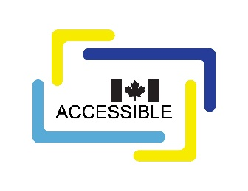
CAN-ASC-4.1 – Accessible Procurement
No part of this publication may be reproduced in any form without the prior permission of the publisher.
The publication is available in HTML format at CAN-ASC-4.1 Accessible Procurement - Accessibility Standards Canada.
For more information, or for alternative formats, contact:
Accessibility Standards Canada
320, Saint-Joseph Boulevard, Suite 246
Gatineau, QC J8Y 3Y8
1-833-854-7628
accessible.canada.ca
© His Majesty the King in Right of Canada, as represented by the Minister responsible for the Accessible Canada Act, 2026.

CAN-ASC-4.1 – Accessible Procurement

Overview
CAN-ASC-4.1 – Accessible Procurement aligns with priority areas on the procurement of goods, services and facilities of the Accessible Canada Act. It aims to ensure a barrier-free Canada by 2040. This standard addresses common areas where people with disabilities may experience barriers to accessibility in procurement such as:
- buying or leasing goods and services that are not accessible,
- inflexible procurement processes,
- inaccessible bidding and evaluation criteria, and
- procurement communications or documents that are not provided in accessible or alternate formats.
Such barriers can prevent the full participation of people with disabilities, including organizations, employees and businesses.
Accessible procurement has been identified as a new concept. Many organizations have not integrated accessibility into the procurement process. Integrating accessibility into procurement reduces and removes barriers for:
- employees and the public who interact with goods and services procured by organizations, and
- businesses who sell goods and services and participate in procurement processes.
This is the first version of the standard CAN-ASC-4.1 – Accessible Procurement. It was prepared by the Technical Committee on Accessible Procurement. The committee operates under the authority of Accessibility Standards Canada.

The CAN-ASC-4.1 – Accessible Procurement provides a framework to help organizations understand how to integrate accessibility into the procurement process. The standard improves accessibility and addresses barriers by providing a framework to help organizations:
- define roles and responsibilities that require their clients to:
  - consider and integrate accessibility requirements into procurement specifications for a good or service, and
  - provide a mandatory justification that explains the decision-making process when accessibility requirements are not included,
- define roles and responsibilities that require their procurement professionals to:
  - support their clients in considering and integrating accessibility into their procurement specifications, and perform a challenge function when accessibility has not been considered,
- integrate accessibility requirements when designing and delivering tools to support the procurement process,
- ensure accessibility is included throughout the procurement lifecycle including:
  - planning a procurement,
  - bidding and contract award, and
  - managing and closing out a contract,
- design and deliver accessible engagement activities with external businesses, and
- provide training to their employees to help them understand and apply accessibility in procurement activities.
By following these requirements, organizations can create and deliver procurement processes that are inclusive and accessible.

