
Overview of Draft Standard

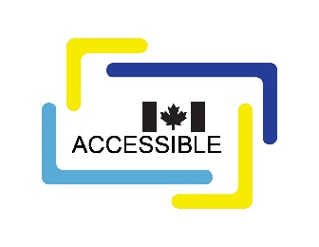
CAN-ASC-2.11 – Accessible-Ready Modular and Prefabricated Housing
No part of this publication may be reproduced in any form without the prior permission of the publisher.
The publication is available in HTML format at CAN-ASC-2.11 – Accessible-Ready Modular and Prefabricated Housing – Accessibility Standards Canada.
For more information, or for alternative formats, contact:
Accessibility Standards Canada
320 Saint-Joseph Boulevard, Suite 246
Gatineau, QC J8Y 3Y8
1-833-854-7628
accessible.canada.ca
© His Majesty the King in Right of Canada, as represented by the Minister responsible for the Accessible Canada Act, 2026.

CAN-ASC-2.11 – Accessible-Ready Modular and Prefabricated Housing

Overview
With the growing need for accessible housing, modular and prefabricated housing are being used more across Canada. This is because they can be delivered quickly and at scale. This Standard sets clear expectations to ensure that accessibility is built into the design and manufacturing of these homes from the start. It supports personalized, needs-based features that can adapt as user’s needs change over time.
CAN-ASC-2.11 – Accessible-Ready Modular and Prefabricated Housing aligns with the Built Environment priority area of the Accessible Canada Act, which aims to create a barrier-free Canada by 2040.
This Standard outlines the requirements and use of the flexible design framework for accessible-ready modular and prefabricated housing. The requirements in this Standard are intended to help to reduce barriers associated with:
- access to and around the home,
- everyday use inside the home,
- moving between levels, and
- future adaptability and safety.
This Standard advances inclusion and equity by increasing the supply of usable housing and reducing barriers to future adaptation. As a result, it provides greater choice and supports safer, more independent living for people with disabilities, while improving comfort and flexibility for everyone.
This is the first edition of CAN-ASC-2.11 – Accessible-Ready Modular and Prefabricated Housing. It was developed by the Technical Committee for the Existing Built Environment. The committee operates under the authority of Accessibility Standards Canada.
The Accessible-Ready Modular and Prefabricated Housing draft standard includes requirements for:
- exterior areas and clearances,
- parking structures and garages,
- interior areas, rooms, spaces (e.g., kitchens and bathrooms) and circulation,
- operating controls,
- stairs and vertical paths of travel,
- doors,
- structural, mechanical and electrical systems, and
- emergency egresses.

